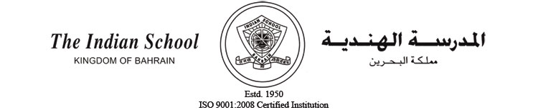
Ref. : ISB/PP/CR/16/15 Date : 28/2/2015
CIRCULAR-16

Academic Session 2015-2016 for Class XII

Dear Parent,

Please be informed that the academic session 2015-2016 for students of Class XII will commence from Wednesday, 11 March 2015. Students should strictly adhere to the dress code and discipline code (refer page 26 and page 30 of the School Diary).

With best regards,

V R Palaniswamy
Principal

